10 Essential Tips for Effective Networking: Building Meaningful Connections
Published on 19 September 2024 at 13:54
Author: Kimberly Wiethoff
In today’s interconnected world, networking has become a crucial skill for career growth and personal development. Whether you're looking to advance your career, explore new opportunities, or simply expand your professional circle, building a strong network can open doors that would otherwise remain closed. However, effective networking isn’t just about collecting business cards or sending out LinkedIn requests; it's about fostering genuine relationships that can lead to lasting partnerships and mutual growth.
In this blog post, we’ll explore 10 essential tips to help you master the art of networking and build meaningful, long-lasting connections.

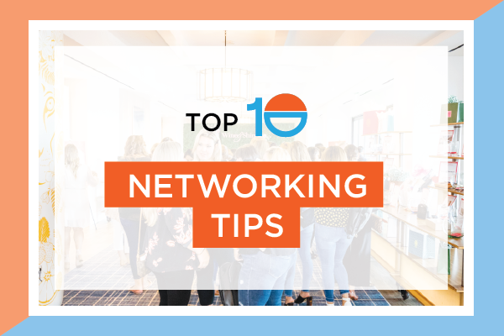
1. Be Genuine and Authentic
The foundation of successful networking lies in authenticity. People are more likely to connect with you if they feel you are being real and sincere. Approach each interaction with a genuine desire to learn about the other person, rather than seeing it as a transactional opportunity. Being yourself not only makes the conversation more natural but also helps to foster trust.
2. Prepare Your Elevator Pitch
You never know when you’ll meet someone who could be instrumental in your professional journey. Having a concise, engaging elevator pitch that highlights your skills, experiences, and what you bring to the table can help you leave a lasting impression. Keep it brief—around 30 seconds—and make sure it's tailored to the person you’re speaking with.
3. Focus on Building Relationships, Not Just Contacts
Effective networking is about quality over quantity. Instead of collecting as many business cards as possible, aim to develop deeper, more meaningful relationships. Networking is an ongoing process, so take the time to nurture the connections you make, offering value wherever possible.
4. Leverage Social Media Platforms
In today’s digital world, social media platforms like LinkedIn, Twitter, and industry-specific groups provide ample opportunities for networking. Engage with professionals in your field by sharing insights, commenting on posts, and staying active. These platforms allow you to connect with people across the globe, making it easier to build your personal brand and establish relationships.
5. Attend Industry Events
Whether virtual or in-person, industry events are a great place to meet like-minded professionals. Conferences, seminars, workshops, and even webinars provide a platform to connect with people in your industry. Be proactive—introduce yourself, join discussions, and exchange contact information with new acquaintances.
6. Follow Up After Initial Meetings
One of the biggest mistakes in networking is failing to follow up. After meeting someone, send a brief follow-up message or email. Mention something specific from your conversation to show that you were truly engaged and interested in what they had to say. This simple step can go a long way in keeping the relationship alive.
7. Be a Good Listener
Networking isn’t just about talking about yourself—it's about listening to others. When you engage with people, ask thoughtful questions, and actively listen to their responses. This shows that you value their insights and are interested in building a meaningful connection.
8. Offer Help Before Asking for It
Networking is a two-way street. Before you ask for something, look for ways you can offer value to the other person. Whether it’s sharing industry knowledge, offering an introduction to someone in your network, or simply providing feedback, helping others is a great way to build goodwill. The more you give, the more likely people will be to help you when the time comes.
9. Be Consistent and Stay in Touch
Building a network doesn’t happen overnight. It requires consistency and effort. Stay in touch with your connections through regular check-ins, sharing relevant information, or engaging with their content on social media. This helps keep you top-of-mind and strengthens your professional relationships over time.
10. Step Out of Your Comfort Zone
Networking can feel intimidating, especially when you’re meeting new people or reaching out to high-level professionals. However, it’s essential to step out of your comfort zone to expand your network. Take the initiative to introduce yourself to new people, attend events where you don’t know anyone, and approach senior professionals with confidence. You’ll be surprised at how many doors can open when you take that first step.

