Leveraging Dashboards for Project Performance
Published on 19 April 2024 at 13:57
Author: Kimberly Wiethoff
In today's fast-paced business environment, effective project management is crucial for success. Whether you're overseeing a software development project, a marketing campaign, or a construction endeavor, keeping a close eye on project metrics is essential for staying on track and achieving objectives. This is where dashboards come into play.
Dashboards offer a centralized platform for monitoring and analyzing project metrics in real time, providing project managers and stakeholders with valuable insights into project performance. By leveraging dashboards effectively, teams can make informed decisions, identify potential issues early on, and optimize processes to ensure project success.
Understanding Dashboards
Dashboards are visual representations of data that offer a snapshot of key performance indicators (KPIs) and metrics relevant to a specific project or business function. They typically consist of charts, graphs, tables, and other visual elements that provide a clear and concise overview of performance.
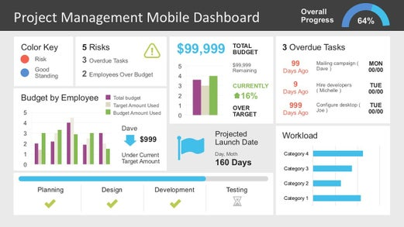
Benefits of Using Dashboards for Project Performance
- Real-time Visibility: Dashboards provide real-time updates on project metrics, allowing stakeholders to track progress and performance at any given moment. This real-time visibility enables proactive decision-making and helps teams respond swiftly to changes or challenges.
- Data-driven Insights: By consolidating relevant data into one accessible platform, dashboards facilitate data-driven decision-making. Project managers can analyze trends, identify patterns, and gain valuable insights into project performance, enabling them to make informed decisions that drive success.
- Improved Communication: Dashboards serve as a common point of reference for all project stakeholders, fostering transparency and improving communication. Instead of relying on lengthy reports or email updates, stakeholders can access the dashboard to get the information they need quickly and easily.
- Identifying Trends and Patterns: Dashboards enable teams to identify trends, patterns, and correlations within project data. By visualizing these insights, teams can uncover areas of improvement, optimize processes, and capitalize on opportunities for growth.
- Customization and Flexibility: Modern dashboard solutions offer customization options, allowing users to tailor the dashboard layout and content to their specific needs. Whether it's tracking financial metrics, monitoring team productivity, or measuring customer satisfaction, dashboards can be customized to reflect the unique requirements of each project.
Best Practices for Designing Effective Dashboards
- Define Key Metrics: Identify the most important metrics and KPIs that align with your project objectives. Focus on quality over quantity and ensure each metric provides actionable insights into project performance.
- Keep it Simple: Avoid cluttering the dashboard with unnecessary information or overly complex visualizations. Aim for simplicity and clarity to ensure that stakeholders can easily interpret the data presented.
- Use Visualizations Wisely: Choose appropriate chart types and visualizations to communicate your data effectively. Whether it's a line graph, bar chart, or pie chart, select the visualization that best represents the information you're trying to convey.
- Provide Context: Contextualize the data by providing relevant background information, trends, and benchmarks. This helps stakeholders understand the significance of the metrics displayed and enables more informed decision-making.
- Regular Updates and Maintenance: Keep the dashboard up to date with regular updates and maintenance. Ensure that data feeds are synchronized, and any changes or updates to metrics are reflected in the dashboard in a timely manner.
Conclusion
In conclusion, dashboards are powerful tools for monitoring and analyzing project metrics, providing stakeholders real-time visibility into project performance. By leveraging dashboards effectively, project managers can make informed decisions, improve communication, and drive project success. By following best practices for dashboard design and implementation, teams can harness the full potential of dashboards to optimize project performance and achieve their objectives.

