Digital Twins & AI: Transforming the Role of Project Managers in Supply Chain Optimization
Published on 24 March 2025 at 09:27
Author: Kimberly Wiethoff
In today’s fast-paced, tech-driven world, global supply chains are more complex—and more connected—than ever before. From raw material sourcing to last-mile delivery, every node and link in the chain generates data. For project managers, the key to staying ahead isn’t just in managing tasks and timelines—it's in harnessing the power of emerging technologies like Digital Twins and Artificial Intelligence (AI) to optimize performance, reduce risk, and improve decision-making.
Let’s explore how these technologies are transforming supply chain management—and what that means for you as a project manager.

What Are Digital Twins in Supply Chain?
A digital twin is a real-time, virtual replica of a physical object, process, or system. In the supply chain world, digital twins can model everything from manufacturing lines and warehouse operations to entire logistics networks.
Imagine having a dashboard that shows you not just where your shipments are, but how warehouse capacity, port congestion, or even weather patterns might impact delivery—and lets you simulate “what if” scenarios before making decisions.
For project managers, this means:
- Real-time visibility across operations
- Predictive modeling to assess the impact of delays, changes, or disruptions
- Scenario planning to test strategies before implementing them
- Faster problem-solving through data-driven insights

How AI Is Revolutionizing Supply Chain Decisions
AI enhances supply chains by analyzing vast amounts of data, identifying patterns, and making intelligent recommendations or automating processes. In logistics and global operations, AI can:
- Forecast demand with greater accuracy
- Optimize routing and shipping schedules
- Detect anomalies or fraud in procurement and invoicing
- Recommend inventory adjustments before stockouts or overstocks occur
As a project manager, AI-powered tools allow you to:
- Make smarter, faster decisions with confidence
- Automate routine tasks, freeing time for strategic thinking
- Improve collaboration by giving teams access to consistent, real-time data
- Identify and mitigate risks before they escalate

The Evolving Role of the Project Manager
With these technologies in play, the traditional PM role is evolving. You’re no longer just tracking progress or managing resources—you’re expected to be a technology translator, a data-savvy strategist, and a collaboration catalyst across globally dispersed teams.
Here are some ways your role might shift:
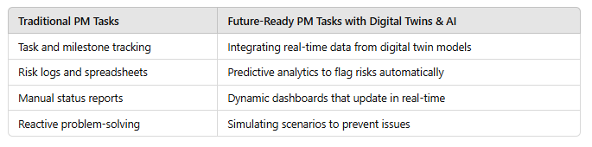

Tips for Project Managers Embracing These Tools
- Learn the Language of Data – Understand the basics of machine learning, AI algorithms, and data interpretation. You don’t need to be a data scientist—but you should know how to ask the right questions.
- Choose the Right Tools – Look for platforms that integrate with your current systems (e.g., ERP, WMS, TMS) and offer transparency across the value chain.
- Pilot Before Scaling – Start with a small project or region. Use it as a proof of concept before rolling out tech-enabled changes company-wide.
- Partner with IT and Data Teams – Break silos and collaborate closely with technical experts. Their input will be critical in customizing models for your supply chain realities.
- Focus on People, Not Just Tech – New tools are only as effective as the people using them. Invest in training and change management so your teams embrace the shift.

Final Thoughts
Digital twins and AI aren’t just buzzwords—they’re powerful enablers of smarter, more resilient global supply chains. As a project manager, your value lies in being the bridge between people, processes, and technology. By embracing these tools, you can drive innovation, boost performance, and deliver results that go beyond on-time delivery.
The future of global supply chain management is already here—and project managers who adapt will lead the way.

Want help evaluating tools or building a roadmap for tech-enabled project management? Let’s connect—I’m always up for a conversation about the intersection of innovation and execution.
#ProjectManagement #SupplyChainManagement #DigitalTwins #ArtificialIntelligence #LogisticsInnovation #AIinSupplyChain #GlobalOperations #SmartLogistics #TechDrivenPM #FutureOfWork #DigitalTransformation #PredictiveAnalytics #AgileSupplyChain

