Infrastructure vs. Software Development Project Management: Understanding the Differences
Published on 23 April 2025 at 13:07
Author: Kimberly Wiethoff
In the world of IT, not all project management is created equal. While both infrastructure and software development projects require planning, coordination, and execution, the nature of the work, timelines, risks, and stakeholder expectations vary significantly. Understanding these differences is critical for assigning the right project manager and ensuring project success.

🛠️ Infrastructure Project Management: Building the Foundation
Infrastructure project management focuses on hardware, networks, data centers, cloud migration, and systems integration. These projects often involve setting up or upgrading physical or virtual environments that support business operations.
Key Characteristics:
- Scope: Includes tasks like setting up servers, configuring firewalls, provisioning cloud resources (AWS, Azure), and ensuring system uptime.
- Dependencies: Strong reliance on external vendors, physical installation timelines, and change control boards.
- Change Risk: Infrastructure changes often carry high operational risk, potentially impacting the entire organization.
- Team Composition: Involves system admins, network engineers, cybersecurity experts, and cloud architects.
- Success Metrics: Measured by uptime, performance benchmarks, capacity, security compliance, and service continuity.

💻 Software Development Project Management: Creating Solutions
Software development project management is centered on building, customizing, or enhancing applications. These could be customer-facing platforms, internal tools, or mobile apps, usually developed using Agile or hybrid methodologies.
Key Characteristics:
- Scope: Includes user stories, backlog grooming, sprint planning, code deployment, and testing cycles.
- Dependencies: Tied closely to internal development resources, code repositories, product owners, and iterative delivery cycles.
- Change Risk: Typically easier to rollback changes; CI/CD pipelines and version control reduce risk.
- Team Composition: Involves developers, UX/UI designers, QA testers, product managers, and Scrum Masters.
- Success Metrics: Focused on feature delivery, user adoption, code quality, velocity, and customer feedback.

🔍 Key Differences at a Glance:
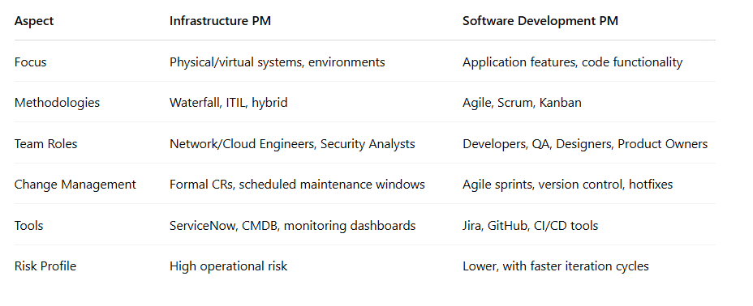

✅ Final Thoughts
Project managers in both domains need strong leadership, stakeholder communication, and risk management skills. However, infrastructure PMs lean toward operational stability and system integrity, while software PMs focus on product value, feature delivery, and user experience. Knowing where your strengths lie—or cross-training in both—can make you an invaluable asset in today's hybrid tech environments.
#ProjectManagement #ITInfrastructure #SoftwareDevelopment #AgilePM #ITProjectManager #DigitalTransformation #TechLeadership #ScrumMaster #CloudMigration

