EHR Integrations That Simplify Your Revenue Cycle
Published on 21 April 2025 at 16:27
Author: Kimberly Wiethoff
In today’s fast-paced healthcare environment, managing the revenue cycle efficiently is just as important as delivering quality patient care. Yet, for many practices, fragmented systems and manual processes create unnecessary delays and errors in billing. That’s where integrating your Electronic Health Record (EHR) system with billing and revenue cycle tools can make all the difference.
A well-integrated EHR doesn't just store clinical data—it becomes a central hub that drives clean claims, accurate coding, faster payments, and better financial visibility. Here's how EHR integration can simplify your revenue cycle from start to finish.

1. Seamless Data Flow from Clinical to Billing
When your EHR is integrated with billing software, there’s no need to re-enter information or transfer data manually. Patient demographics, insurance details, diagnoses, and procedure codes flow directly from the clinical chart to the claim.
Benefit: Fewer errors, less rework, and reduced claim denials.

2. Real-Time Eligibility Verification
Integrated systems can check insurance eligibility before the patient is even seen. This ensures your front desk collects the right co-pay and confirms coverage for services—reducing the risk of rejected claims.
Pro Tip: Look for integrations that provide batch eligibility checks for upcoming appointments.

3. Streamlined Coding and Charge Capture
When providers document directly into an EHR with built-in coding support, accurate CPT and ICD-10 codes are applied automatically. Some platforms even suggest codes based on documentation, reducing missed charges.
Result: More complete claims and higher reimbursement.

4. Integrated Claim Scrubbing and Submission
A connected EHR can include a claim scrubbing engine that checks for errors before the claim is sent. This saves time and improves your clean claim rate—a key metric in revenue cycle health.
Time-Saver: No need to log into separate portals or export/import files manually.

5. Consolidated Reporting and Analytics
When your EHR and billing data live in the same ecosystem, you get real-time insights into:
- Days in A/R
- Denial trends
- Revenue per visit
- Outstanding patient balances
This visibility allows you to make faster, smarter decisions that improve cash flow.

6. Easier Compliance and Audit Readiness
EHR integrations also support better documentation and audit trails. Everything from consent forms to progress notes to billing codes is linked, creating a complete record of the patient visit that meets payer and regulatory requirements.

Final Thoughts
An EHR that integrates smoothly with your billing system is more than a convenience—it’s a strategic asset. It boosts productivity, reduces billing errors, and accelerates payment cycles. Whether you're a small practice or a multi-specialty clinic, investing in a fully integrated system will pay dividends in both time and revenue.

#EHRIntegration #MedicalBilling #RCM #RevenueCycleManagement #HealthcareTechnology #MedicalCoding #CleanClaims #PracticeEfficiency #EHRWorkflow #HealthIT #BillingAutomation #HealthcareFinance #PracticeManagement #ClaimScrubbing #MedicalPracticeTips

Top EHR Platforms with Strong Billing Integrations (2025 Checklist)
Here's a checklist of top EHR platforms with strong billing integrations, followed by a visual flowchart description.

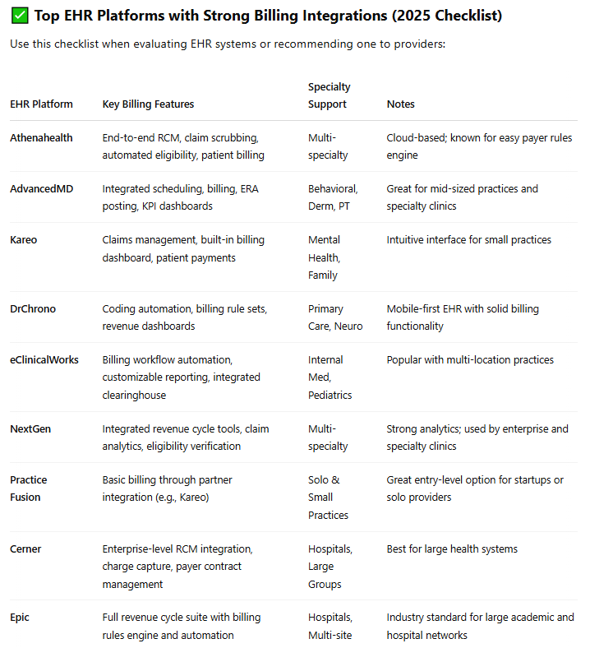

🔄 Visual Flowchart Description: EHR + Billing Integration Workflow
This workflow diagram illustrates the **HIPAA-compliant, end-to-end process** of EHR and billing system integration in a modern healthcare setting. From the moment a patient schedules an appointment to the final posting of payments and generation of patient statements, each step is optimized for both **efficiency and security**. Key touchpoints—like eligibility verification, claim generation, and data posting—are safeguarded with encryption and access controls to protect PHI. When systems are seamlessly connected, practices can accelerate reimbursements, reduce administrative burden, and maintain full compliance with HIPAA standards.
