The True Cost of In-House Billing vs. Outsourcing
Published on 20 April 2025 at 15:31
Author: Kimberly Wiethoff

A Side-by-Side Comparison
When it comes to medical billing, the decision to keep it in-house or outsource to a professional billing company is a critical one. Many practices assume that handling billing internally is more cost-effective—but the numbers often tell a different story. In fact, when you account for staffing, software, claim delays, and compliance risks, outsourcing may offer greater value than you think.

Let’s break down the real costs and benefits of both approaches.

In-House Billing: What's Really Involved?
At first glance, having your own billing staff might seem like the most straightforward option. However, the true cost includes much more than just salaries. Consider:
- Salaries and Benefits: Hiring experienced billing professionals can cost $45K–$70K per year per employee—not including benefits, paid time off, or turnover costs.
- Software and Licensing: Billing software, clearinghouse fees, and updates can add up to thousands annually.
- Training and Management: Ongoing training is needed to stay current on ICD/CPT changes and payer requirements. Someone also has to manage the billing team, track metrics, and resolve escalations.
- Risk of Errors: Coding mistakes and missed deadlines can lead to denials, audits, or even compliance fines—costing you money and time.

Outsourced Billing: What Are You Paying For?
Outsourced billing companies typically charge a percentage of collections (usually 4%–8%). While this may seem like a high cost upfront, what you’re really paying for includes:
- Access to Certified Coders and RCM Experts
- Automated Tools and Real-Time Reporting
- Consistent Claim Submission and Denial Management
- Regulatory Compliance and Risk Reduction
- Scalability—services can grow as your practice grows
Most importantly, they are incentivized to get you paid. The more you collect, the more they earn—so their goals are aligned with yours.

The Comparison: In-House vs. Outsourced
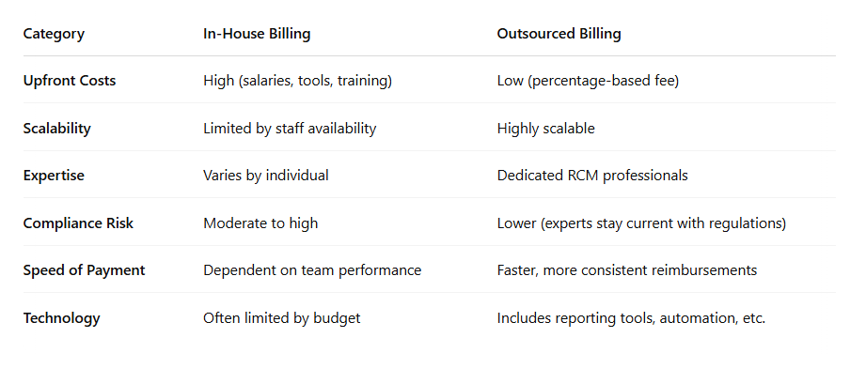

Making the Right Decision
If your in-house billing team is strong, well-managed, and up-to-date on compliance, it may be worth continuing. However, if you're dealing with staff turnover, cash flow issues, or slow claim processing, outsourcing could save you time, money, and stress.
The best solution? Run the numbers. Compare your total in-house billing expenses with potential outsourced fees—and factor in the long-term value of faster reimbursements, fewer denials, and peace of mind.

#MedicalBilling #RCM #HealthcareFinance #PracticeManagement #OutsourceBilling #RevenueCycle #MedicalBillingSolutions #HealthcareOperations #MedicalBillingTips #CostAnalysis #HealthcareCompliance #CleanClaims #HealthcareProductivity

