Expectation Management: A Guide for Project Managers
Published on 7 April 2024 at 19:20
Author: Kimberly Wiethoff

The journey towards realizing expectations is seldom a straightforward one. Instead, it resembles a winding road, filled with unforeseen twists, turns, and obstacles that can lead to deviations from the initial plan. This non-linear path of expectation realization is influenced by various factors, including uncertainty, complexity, dependencies, risks, and human dynamics.
Uncertainty and complexity inherent in projects introduce variability and unpredictability into the path of realizing expectations. As projects unfold, new information emerges, requirements evolve, and external factors come into play, prompting the need for adjustments and adaptations along the way. This iterative nature of projects means that expectations may shift over time as feedback is received and lessons are learned.
Dependencies and interdependencies among project components further contribute to the non-linear path of expectation realization. Changes or delays in one aspect of the project can have cascading effects on other areas, requiring careful management to keep the project on track. Managing dependencies effectively involves identifying, prioritizing, and addressing interconnections to minimize disruptions and maintain alignment with expectations.
Risk and uncertainty also play a significant role in shaping the path of realizing expectations. Unforeseen risks, such as technical challenges, resource constraints, or external factors like market fluctuations, can impact project plans and outcomes. Proactive risk management is essential for identifying potential threats, implementing mitigation strategies, and adapting to changing circumstances to minimize the impact on expectations.
Moreover, human factors, such as communication breakdowns, conflicting priorities, and resistance to change, can further complicate the path of realizing expectations. Misunderstandings, miscommunications, or disagreements among stakeholders can lead to delays, rework, or scope changes that affect project outcomes. Effective stakeholder management and communication are critical for addressing these human dynamics and maintaining alignment with expectations.
As a project manager, one of your key responsibilities is managing the expectations of cross-functional teams to ensure project success. In this blog post, we'll explore effective strategies for clarifying, controlling, and communicating expectations, ultimately fostering collaboration and achieving project goals. Agile project management is a balancing act. One of the 4 Agile Values is responding to change over following a plan.
Listen and Understand:
Effective expectation management begins with active listening and understanding. Take the time to engage with stakeholders from different functional areas, such as marketing, finance, and IT, to gain insights into their needs, concerns, and priorities. By listening attentively and empathetically, you can build rapport, establish trust, and develop a deeper understanding of stakeholders' expectations.
Negotiate:
Once you've gathered input from cross-functional teams, it's essential to negotiate and align expectations to ensure they are realistic and achievable. Collaborate with stakeholders to identify common goals, priorities, and constraints, and work together to establish a shared understanding of project objectives and deliverables. Be prepared to compromise and find win-win solutions that balance competing interests and priorities.
Clarify Expectations:
Clear communication is critical for clarifying expectations and avoiding misunderstandings. Clearly define project scope, timelines, roles, responsibilities, and deliverables, ensuring that all stakeholders have a common understanding of what is expected. Use tools such as project charters, work breakdown structures, and communication plans to document and communicate expectations effectively.
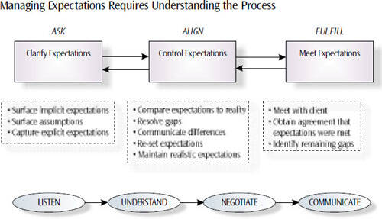
Control Expectations:
As the project progresses, proactively manage and control expectations to address changes, risks, and challenges that may arise. Keep stakeholders informed about project status, milestones, and any deviations from the original plan, providing regular updates and transparent communication. Set realistic expectations about what can be achieved within the project constraints and manage stakeholder perceptions accordingly.
Communicate:
Effective communication is the cornerstone of expectation management. Keep lines of communication open with cross-functional teams, providing opportunities for feedback, questions, and concerns. Use a variety of communication channels, such as meetings, emails, and collaboration tools, to ensure that stakeholders are informed and engaged throughout the project lifecycle. Be responsive to stakeholder inquiries and address issues promptly to maintain trust and credibility.
Path to Realizing Expectations
The path of realizing expectations is often depicted as a straight line from point A (initial expectation) to point B (final outcome). However, in reality, this path is rarely linear. Instead, it is filled with twists, turns, and unexpected challenges that can derail or delay the achievement of desired outcomes. Here's why the path of realizing expectations is not a straight path:
- Uncertainty and Complexity: Projects operate in dynamic environments characterized by uncertainty, complexity, and change. As such, initial expectations may need to be adjusted or refined as new information emerges, requirements evolve, and external factors come into play. Uncertainty and complexity can introduce variability and unpredictability into the path of realizing expectations, making it non-linear.
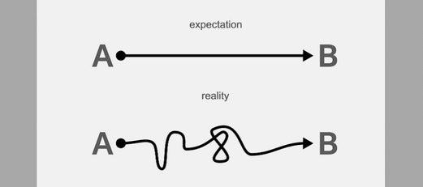
- Dependencies and Interdependencies: Projects often involve multiple stakeholders, tasks, and dependencies that are interconnected and interdependent. Changes or delays in one aspect of the project can have ripple effects on other areas, causing the path of realizing expectations to deviate from its original trajectory. Managing dependencies and addressing interdependencies is crucial for keeping the project on track.
- Risk and Uncertainty: Risk is inherent in every project and can impact the realization of expectations. Unforeseen risks, such as technical challenges, resource constraints, or external factors like market fluctuations or regulatory changes, can disrupt project plans and derail progress. Effective risk management is essential for mitigating risks and minimizing their impact on project outcomes.
- Iterative Nature of Projects: Many projects follow an iterative or incremental approach, where work is completed in stages or phases. This iterative nature means that expectations may evolve over time as feedback is received, lessons are learned, and adjustments are made. Iterative development cycles allow for flexibility and adaptation, but they can also introduce changes and course corrections along the way.
- Human Factors: Human factors, such as communication breakdowns, conflicting priorities, and resistance to change, can affect the path of realizing expectations. Misunderstandings, miscommunications, or disagreements among stakeholders can lead to delays, rework, or scope changes that impact project outcomes. Effective stakeholder management and communication are essential for addressing human factors and maintaining alignment.
In summary, the path of realizing expectations is not a straight path due to uncertainty, complexity, dependencies, risks, iterative development, and human factors. Recognizing and embracing the non-linear nature of this path is essential for project managers and stakeholders to navigate challenges, adapt to changing circumstances, and ultimately achieve successful outcomes.
Conclusion
In conclusion, effective expectation management is essential for project success, particularly when working with cross-functional teams. By listening, understanding, negotiating, clarifying, controlling, and communicating expectations effectively, project managers can foster collaboration, mitigate risks, and achieve project objectives successfully. Remember, managing expectations is an ongoing process that requires proactive engagement and transparent communication throughout the project lifecycle.

