The Project Manager's Crucial Role in Project Risk Management
Published on 31 May 2024 at 15:56
In the realm of project management, navigating uncertainties and mitigating risks are integral parts of ensuring successful project delivery. As the conductor orchestrating the various elements of a project, the project manager plays a pivotal role in identifying, assessing, and managing risks throughout the project lifecycle. Let's explore the key responsibilities and strategies that project managers employ in effective project risk management.
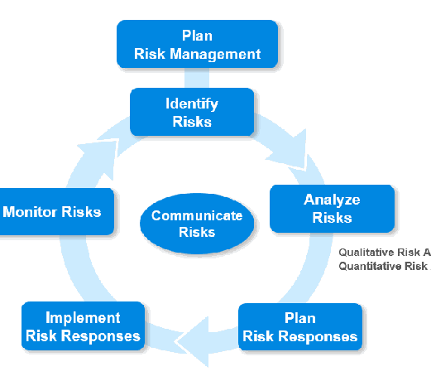
1. Risk Identification:
The first step in managing project risks is to identify them. Project managers collaborate with stakeholders, team members, and subject matter experts to systematically identify potential risks that could impact project objectives. This involves analyzing project documentation, conducting brainstorming sessions, and leveraging historical data from similar projects to uncover potential threats and opportunities.
2. Risk Assessment and Prioritization:
Once risks are identified, project managers assess their potential impact and likelihood of occurrence. By quantifying risks based on their severity and probability, project managers prioritize them according to their significance to project success. This enables project teams to focus their efforts on addressing the most critical risks that pose the greatest threat to project objectives.
3. Risk Mitigation and Response Planning:
After prioritizing risks, project managers develop comprehensive mitigation plans to minimize their impact or likelihood of occurrence. This may involve implementing proactive measures to prevent risks from materializing, transferring risks to third parties through contracts or insurance, or developing contingency plans to address risks if they do occur. Effective risk response planning requires collaboration with stakeholders and subject matter experts to ensure that mitigation strategies are practical, cost-effective, and aligned with project goals.
4. Risk Monitoring and Control:
Risk management is an ongoing process that requires continuous monitoring and control throughout the project lifecycle. Project managers establish mechanisms for tracking identified risks, monitoring changes in their likelihood or impact, and evaluating the effectiveness of risk mitigation strategies. By maintaining open communication channels and conducting regular risk reviews, project managers can proactively identify emerging risks and adapt their approach to risk management as needed.
5. Communication and Stakeholder Engagement:
Effective communication is essential in project risk management. Project managers regularly update stakeholders on the status of identified risks, mitigation efforts, and any changes in risk exposure. By fostering transparent communication and engaging stakeholders in risk management activities, project managers build trust, promote accountability, and ensure that risks are addressed in a timely and collaborative manner.
6. Lessons Learned and Continuous Improvement:
At the conclusion of the project, project managers conduct a thorough review of the risk management process to identify lessons learned and areas for improvement. By capturing insights from both successful risk mitigation efforts and unforeseen challenges, project managers contribute to organizational learning and enhance risk management practices for future projects.
Conclusion
In conclusion, project managers play a critical role in project risk management by leading efforts to identify, assess, mitigate, and monitor risks throughout the project lifecycle. By adopting a proactive and systematic approach to risk management, project managers can minimize the impact of uncertainties, enhance project outcomes, and increase stakeholder confidence in project delivery. Effective risk management is not merely a task—it's a mindset that empowers project managers to navigate challenges with resilience, foresight, and strategic agility.

