What You Need to Know to Be a Project Manager for Workday Finance Module
Published on 25 February 2025 at 13:58
Author: Kimberly Wiethoff
The Workday Finance module is a powerful cloud-based financial management solution that integrates core financial functions such as accounting, procurement, revenue management, and financial planning. As a Project Manager overseeing a Workday Finance implementation, you need to navigate technical configurations, stakeholder expectations, and business process changes to ensure a successful deployment. Here’s what you need to know:
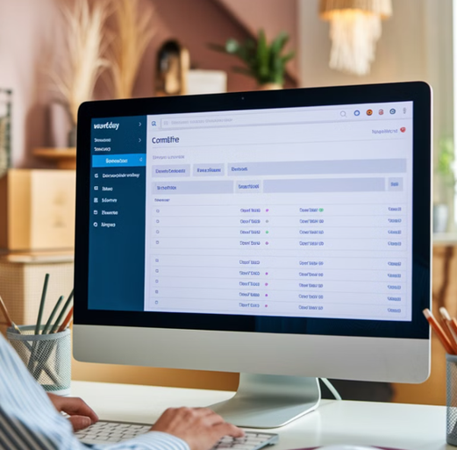

1. Understand Workday Finance Basics
Before managing a Workday Finance project, you should familiarize yourself with its core functionalities:
- ✅ General Ledger (GL) – Real-time financial reporting and multi-ledger capabilities.
- ✅ Accounts Payable (AP) & Accounts Receivable (AR) – Automated invoicing, payments, and collections.
- ✅ Procurement – Supplier management, purchase orders, and expense tracking.
- ✅ Financial Planning & Analytics (FP&A) – Budgeting, forecasting, and analytics using Workday Adaptive Planning.
- ✅ Asset & Expense Management – Fixed assets, depreciation, and expense reimbursement processes.
A strong understanding of these modules helps bridge the gap between technical teams and finance stakeholders.

2. Key Responsibilities as a Workday Finance PM
Your role is to oversee the project lifecycle from planning to post-go-live support. This includes:
- 📌 Project Planning & Governance – Define scope, budget, timeline, and risk mitigation strategies.
- 📌 Stakeholder Management – Work with finance leaders, IT, and Workday consultants to align business requirements.
- 📌 Change Management – Drive process optimization and train end-users on new workflows.
- 📌 Integration & Data Migration – Ensure Workday connects with legacy systems (e.g., SAP, NetSuite) and that data migration is accurate.
- 📌 Testing & Validation – Oversee User Acceptance Testing (UAT) and resolve defects before go-live.
- 📌 Deployment & Hypercare – Provide post-implementation support to address issues and optimize adoption.

3. Workday Implementation Methodology
Workday follows a phased implementation approach:
- 🔹 Plan – Define objectives, governance structure, and project roadmap.
- 🔹 Architect & Configure – Workday consultants configure the system based on business needs.
- 🔹 Test – Perform unit testing, integration testing, and UAT with finance users.
- 🔹 Deploy – Go live with a structured rollout strategy and contingency plans.
- 🔹 Optimize – Provide post-go-live support and continuous process improvements.
Understanding this methodology helps set realistic timelines and expectations.

4. Skills Needed for a Workday Finance Project Manager
To successfully manage a Workday Finance project, you should have:
- ✔ Project Management Expertise – Experience with Agile and Waterfall methodologies (PMP, PMI-ACP certifications help).
- ✔ Financial Acumen – Understanding of accounting principles, financial reporting, and ERP systems.
- ✔ Workday Knowledge – Experience managing ERP implementations, especially Workday or similar systems.
- ✔ Stakeholder & Vendor Management – Ability to collaborate with finance teams, IT, and Workday consultants.
- ✔ Data & Integration Oversight – Ensuring data integrity and seamless integration with third-party applications.
- ✔ Risk & Change Management – Addressing potential disruptions and ensuring smooth adoption.

5. Common Challenges & How to Overcome Them
- ❗ Data Migration Complexities – Ensure clean and structured financial data before migration.
- ❗ Stakeholder Resistance – Communicate the benefits of Workday Finance and provide comprehensive training.
- ❗ Integration Issues – Work closely with IT and Workday consultants to troubleshoot connectivity problems.
- ❗ Customization Requests – Balance out-of-the-box functionality with essential business customizations to avoid scope creep.
- ❗ Regulatory Compliance – Ensure financial reporting aligns with industry standards and regulations.

Final Thoughts
Managing a Workday Finance implementation requires a mix of technical, financial, and project management expertise. By understanding the system’s capabilities, aligning with business needs, and proactively managing risks, you can drive a successful Workday Finance deployment that enhances financial operations and reporting.
🚀 Are you preparing for a Workday Finance project? Share your experiences or questions in the comments!

