Mastering Stakeholder Management in Cross-Functional IT Projects: Tips and Techniques
Published on 12 April 2024 at 09:49
Author: Kimberly Wiethoff
In the realm of IT projects, success isn't just about writing code or implementing systems—it's also about effectively managing stakeholders. These are the individuals or groups who have a vested interest in the project's outcome, ranging from end-users to executives. In cross-functional teams, where diverse expertise converges, stakeholder management becomes even more crucial. Here are some tips and techniques to navigate this complex landscape successfully:
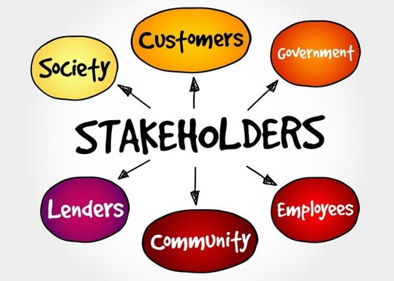
- Identify and Prioritize Stakeholders: Begin by creating a comprehensive list of all potential stakeholders. This includes not only those directly involved in the project but also those who might be impacted by its outcomes. Prioritize them based on their level of influence, interest, and impact on the project.
- Understand Stakeholder Needs and Expectations: Engage with stakeholders early on to understand their needs, expectations, and concerns. Conduct interviews, surveys, or workshops to gather insights. This helps in tailoring project strategies and communication plans to address their specific requirements.
- Establish Clear Communication Channels: Communication is the cornerstone of effective stakeholder management. Set up clear channels for regular updates, feedback loops, and issue resolution. Utilize a combination of emails, meetings, project management tools, and collaboration platforms to ensure information flows seamlessly.
- Customize Communication Styles: Different stakeholders have different communication preferences. Some may prefer detailed reports, while others may prefer quick summaries or face-to-face meetings. Adapt your communication style to resonate with each stakeholder group, ensuring they feel heard and valued.
- Build Trust and Credibility: Trust is earned through transparency, reliability, and competence. Keep stakeholders informed about project progress, challenges, and successes. Be honest about risks and setbacks and demonstrate your ability to address them effectively. Consistently delivering on commitments enhances your credibility.
- Manage Expectations Realistically: Set realistic expectations regarding project scope, timelines, and deliverables. Avoid overpromising to stakeholders, as it can lead to disappointment and erode trust. Instead, under promise and overdeliver by exceeding expectations whenever possible.
- Anticipate and Address Resistance: Change, even positive change, often meets resistance. Be proactive in identifying potential sources of resistance among stakeholders and develop strategies to mitigate them. Address concerns empathetically, provide rationale for decisions, and involve stakeholders in the decision-making process whenever feasible.
- Celebrate Achievements and Milestones: Recognize and celebrate project achievements and milestones publicly. This not only boosts team morale but also reinforces stakeholder confidence in the project's progress and success.
- Continuously Engage and Adapt: Stakeholder management is not a one-time activity but an ongoing process. Continuously solicit feedback, reassess stakeholder needs, and adapt your strategies accordingly. Flexibility and agility are key to effectively managing stakeholder dynamics in a dynamic IT environment.
- Document and Learn from Experiences: Document lessons learned throughout the project lifecycle, including successes, failures, and key insights gained from stakeholder interactions. Use this knowledge to refine your stakeholder management approach in future projects, fostering continuous improvement.
In conclusion, successful stakeholder management in cross-functional IT projects requires a combination of strategic planning, effective communication, relationship building, and adaptability. By prioritizing stakeholder engagement and responsiveness, teams can navigate complex stakeholder landscapes with confidence and achieve project success.

